**Recommender Systems: Matrix Factorization**

These are essentially model-based methods, which alleviates the problem of large computing effort needed for collaborative filtering methods. This problem may not actually suffice though if we are able to do item-based filtering instead, or use big data technologies to aid us.

A legitimate problem in collaborative filtering is its sensitivity to noisy and sparse data.

**Principal Component Analysis (PCA)**

* The basis of matrix factorization techniques.
* Usually described as a dimensionality reduction problem.

**Singular Value Decomposition (SVD)**

* Uses PCA to find a vector which best represents each user/items.

**SVD ++**

* Difference from SVD is fairly subtle. It has to do with the actual loss function that is used while running stochastic gradient descent. In SVD++, this loss function takes into account the idea that merely rating an item at all, is some sort of implicit interest in the item, no matter what the rating was.

**More to Explore**

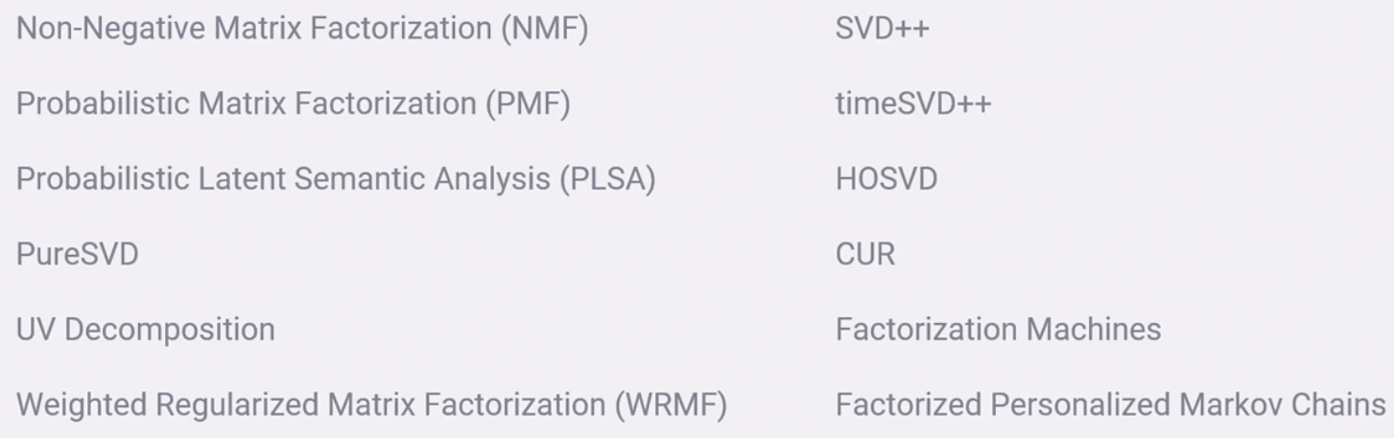

**Sparse Linear Methods**